

Machine Learning-Music Recommendation

Progress Report

| Roll No. | Name of the Student | Name of the Program |
| --- | --- | --- |
| AU1940142 | Shail | ML |
| AU1940267 | Sahil | ML |
| AU1940034 | Varun | ML |

**KNN model created and recommendations recieved**

The KNN model was created which gave us an output of recommended songs based on the songs we had been listening to. The songs which we listened to were passed in the form of a dictionary containing the name and the year of the song. The output that the model gave us were the songs which we would probably like. The output was also a list of songs with the artist name, name of the song and the year it was released in.

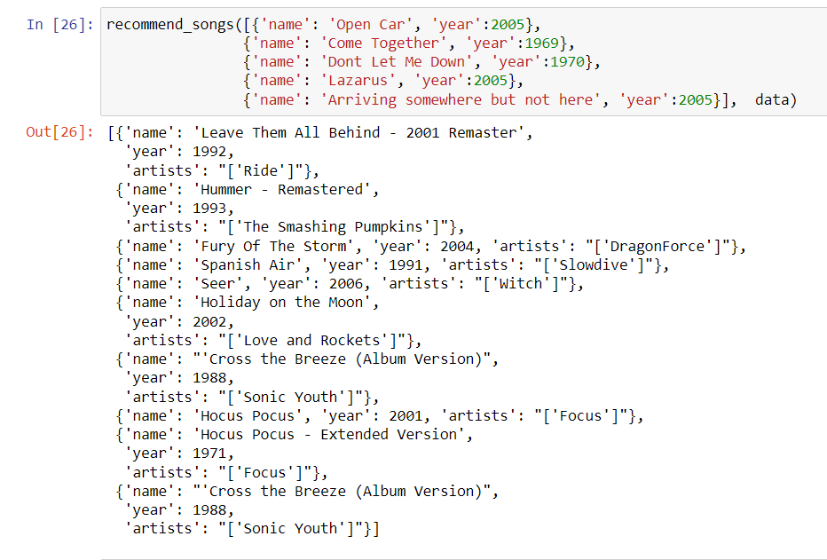

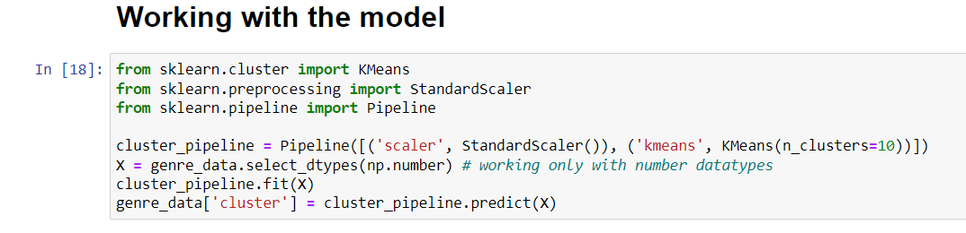

**Future work**

The remaining task is to integrate the spotify account so that we can get a list of the top played songs directly instead of the user needing to put the data manually into the recommendation system.